Please resolve the overlapping field in Anfrage(request for quote).
[ resolve in UserExit ]
Correct version
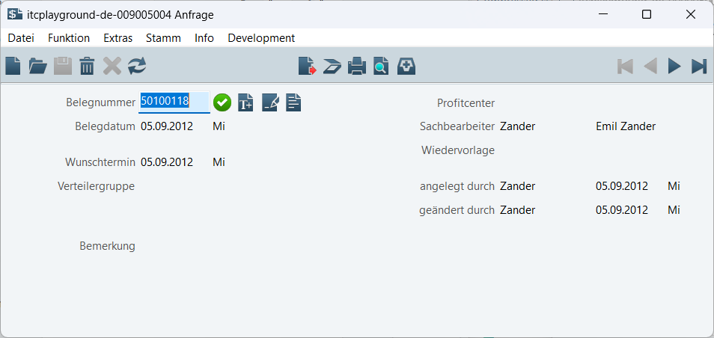
Error version
